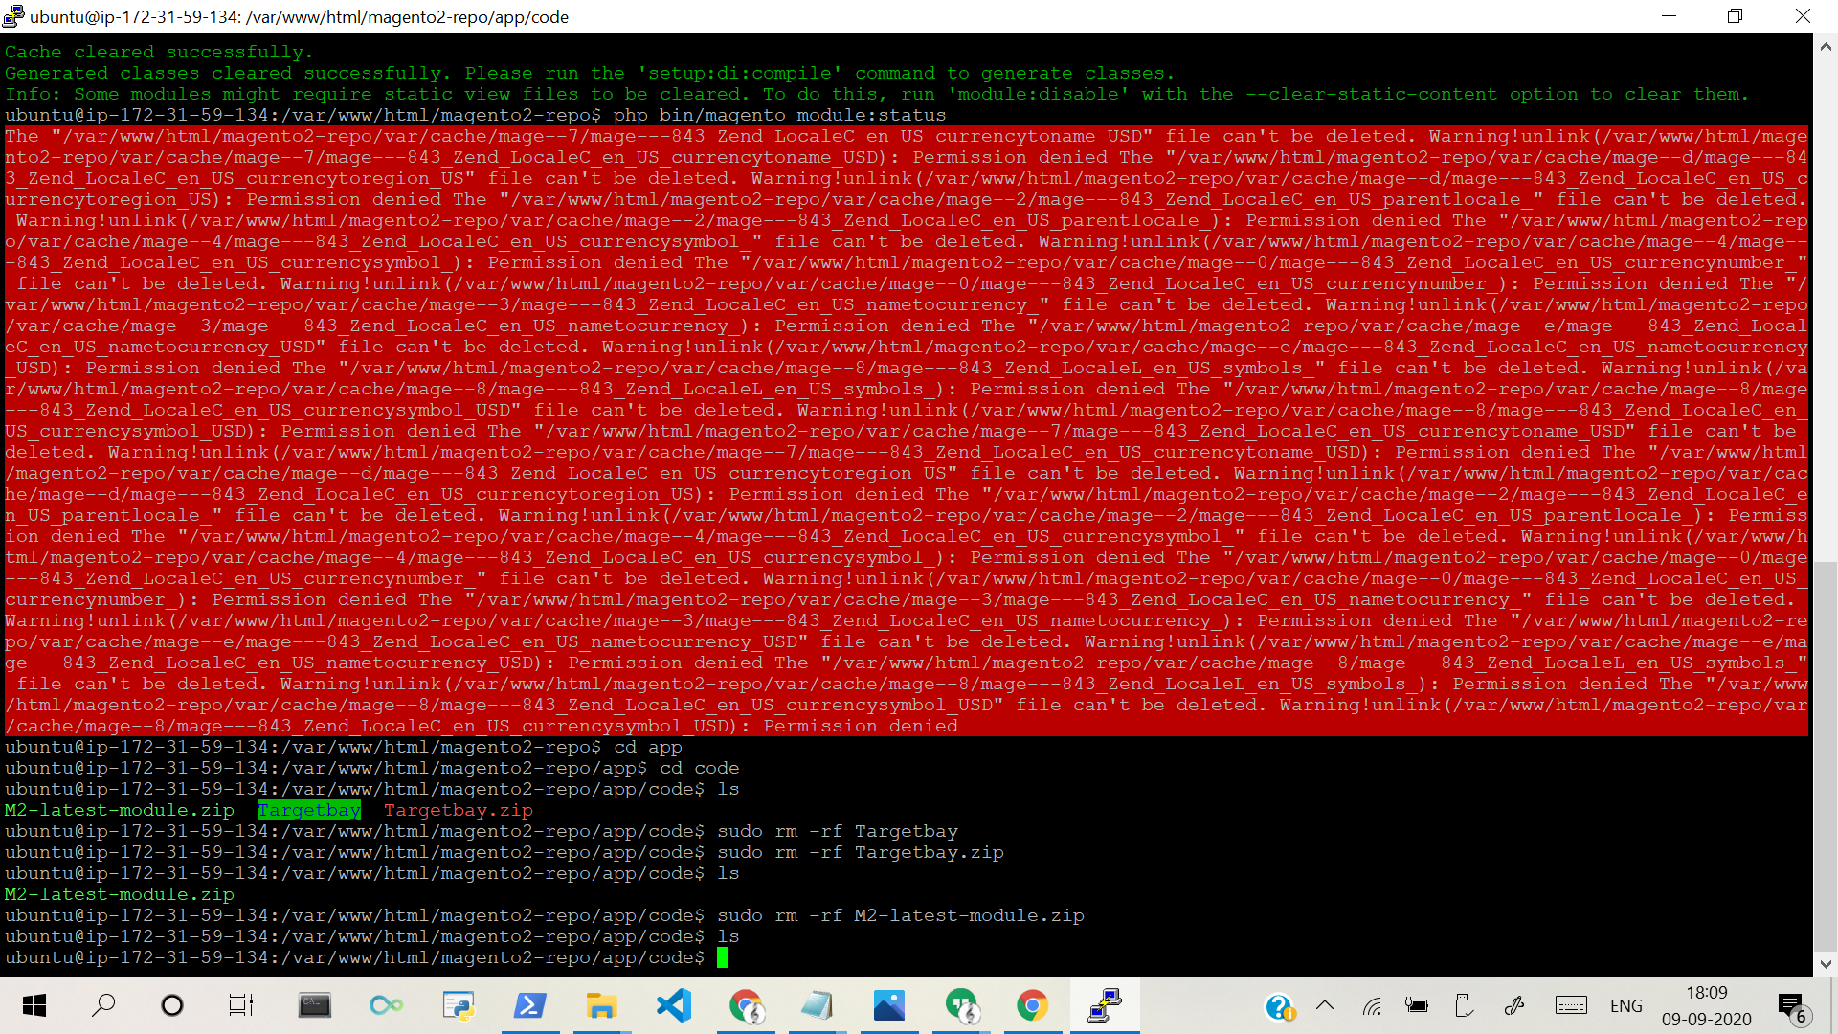

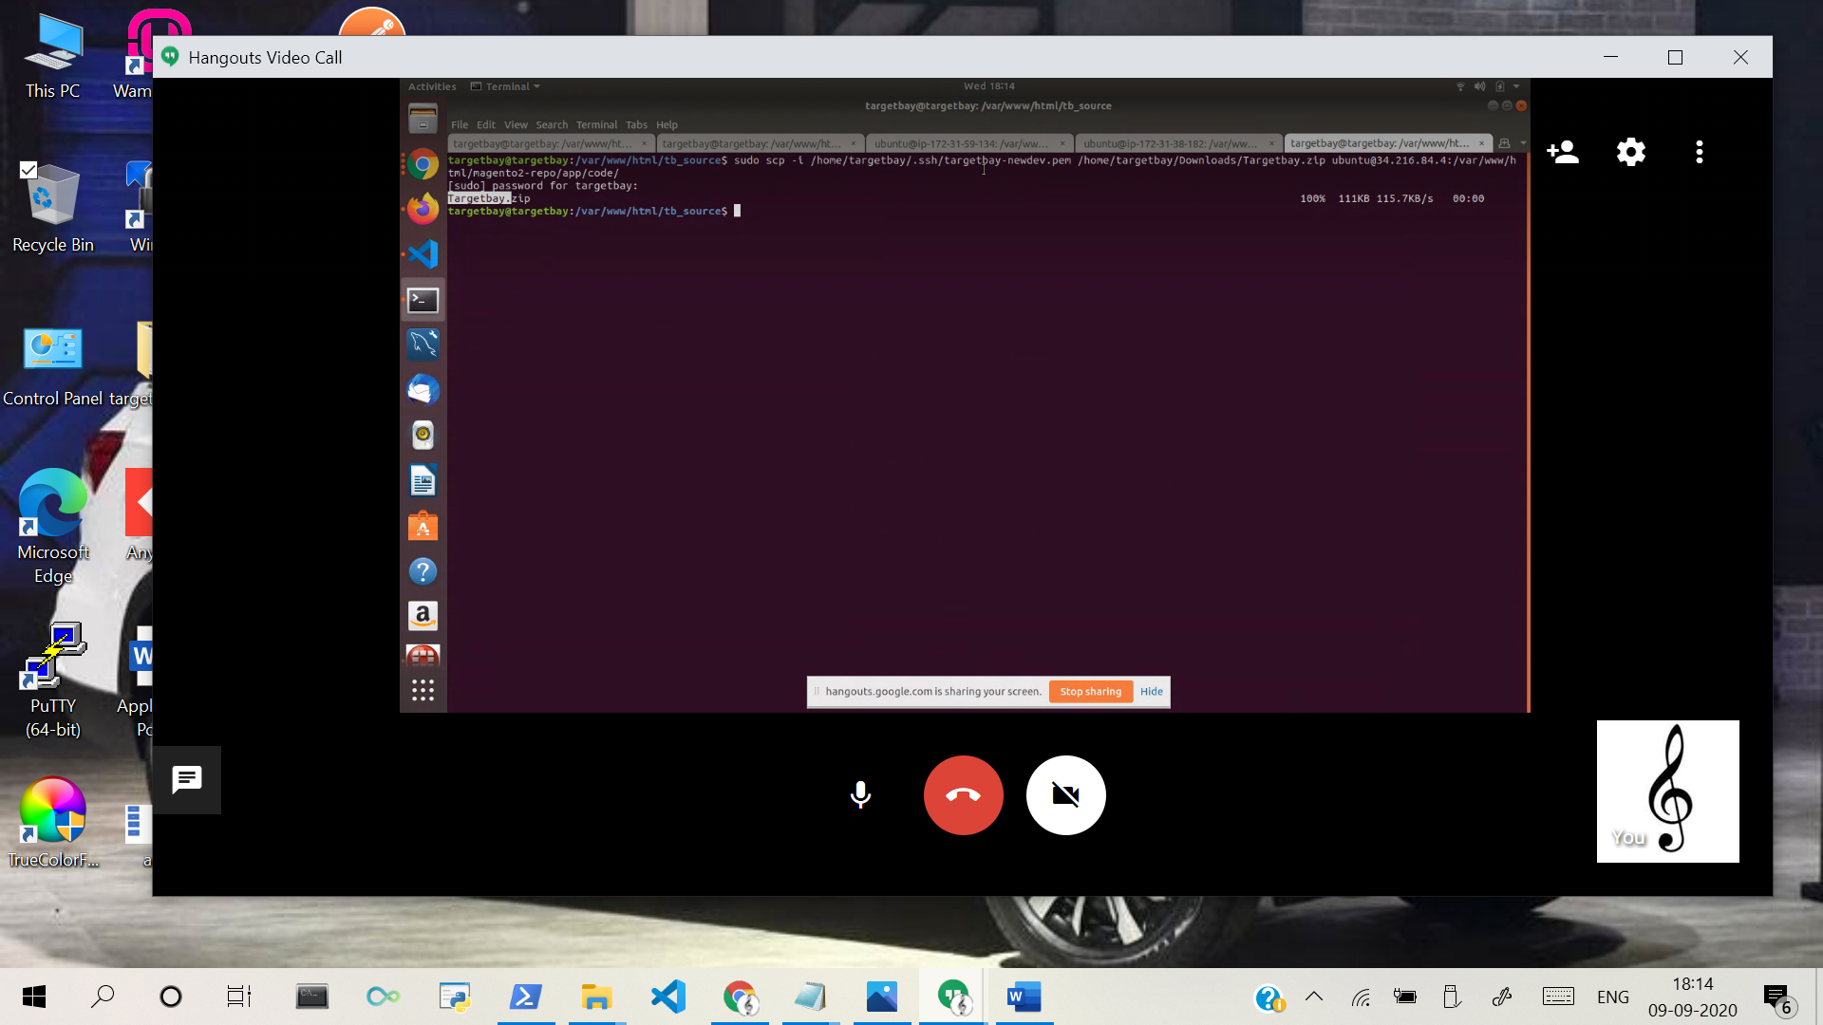

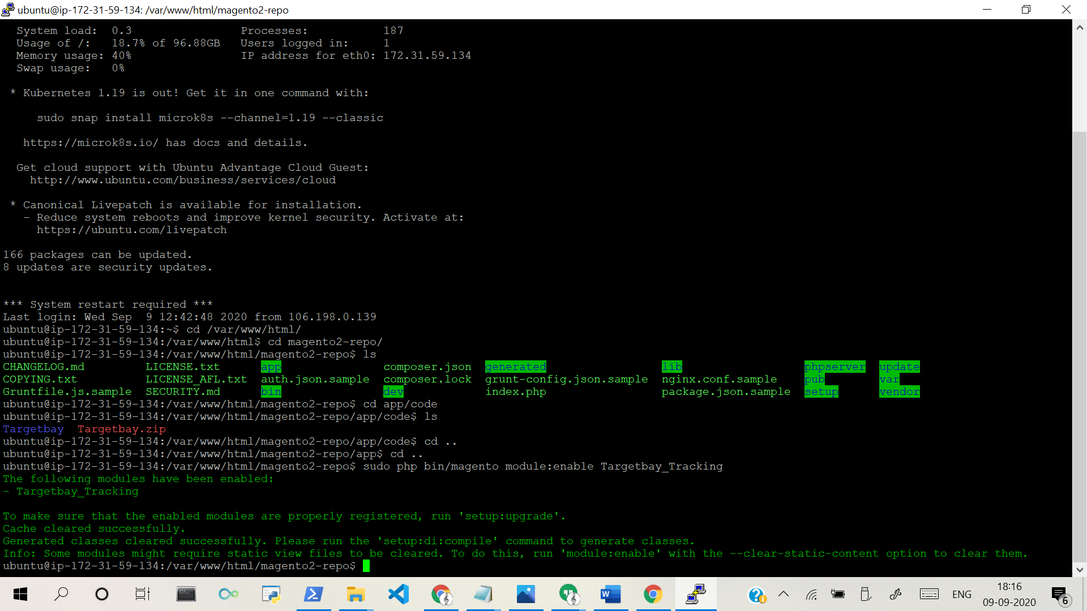

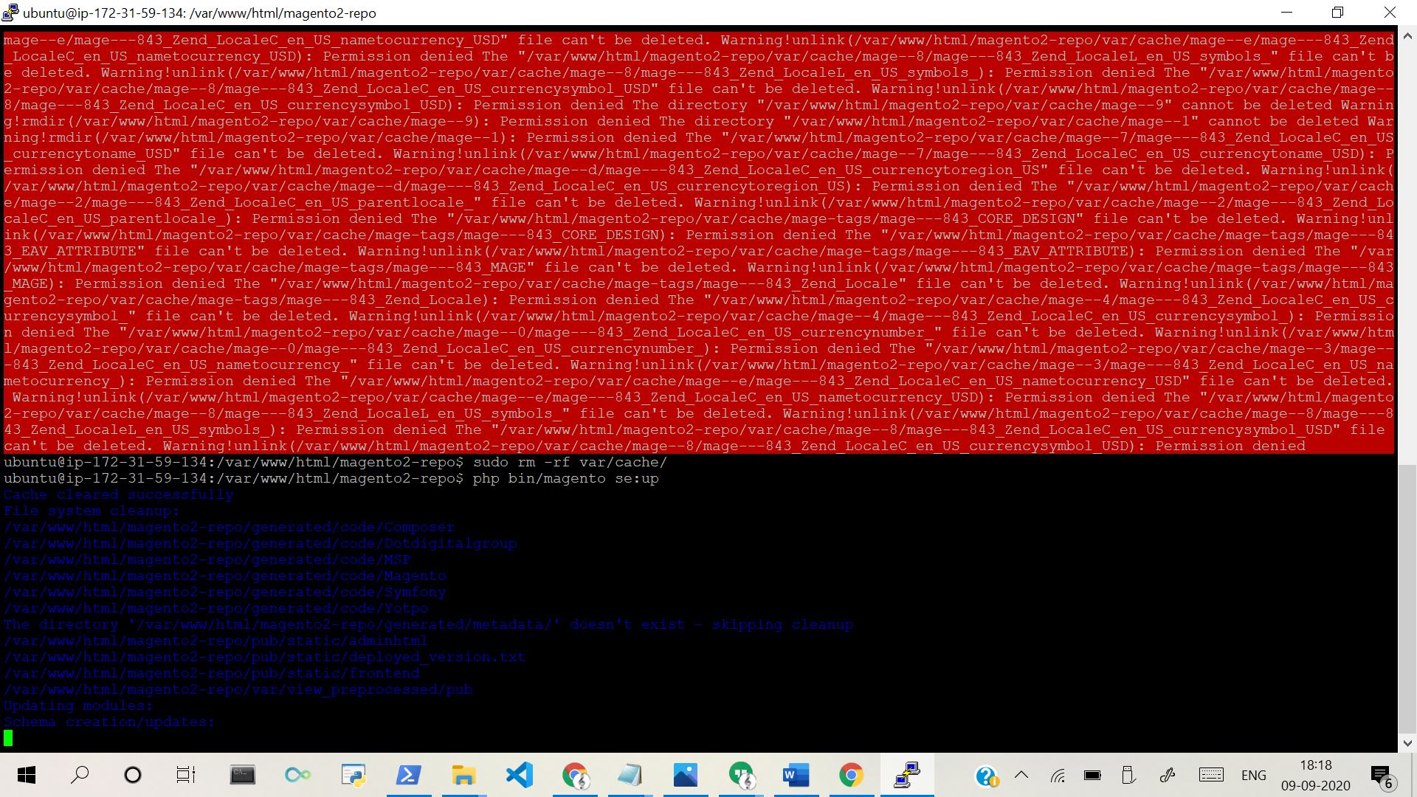

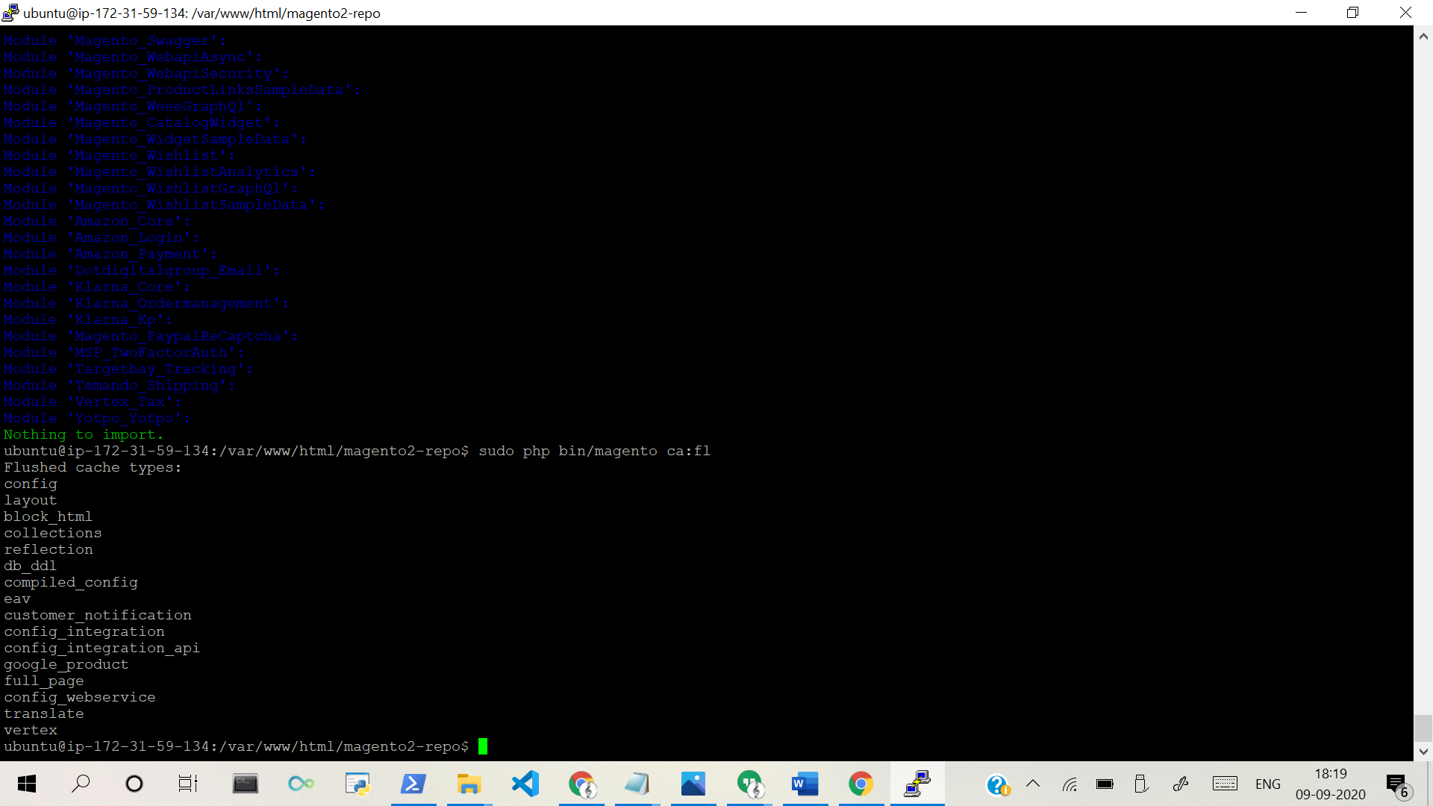

To Check TargetBay Installation status:
---------------------------------------
Step 1: Login to customer server and goto app/code

Step 2 : Check whether Targetbay folder already available inside app/code/ or app/code/mv folder, If so remove it

To Install TargetBay: [From your local environment]
---------------------
Step 1: Move the files from local to customer server:

sudo scp -P 20342 /home/targetbay/Desktop/Magento_Modules/M2_TargetBay_Tracking_2.3/app/code/Targetbay.zip devrokha@sip4-1374.nxcli.net:/dev.rokhardware.com/html/app/code/

Step 2: Then unzip the folder:

unzip Targetbay.zip

Step 3: Goto project root folder

Step 4: Enable TargetBay module

sudo php bin/magento module:enable Targetbay_Tracking

Step 5: Run the following commands
php bin/magento se:up
sudo php bin/magento ca:fl
#sudo rm -rf generated/
sudo rm -rf var/cache/

Step 6: Provide permission to var and pub folder as given below

sudo chmod -R 777 var/ pub/

Step 7: Below code will be need for any css changes [Optional]

php bin/magento s:s:d

Step 8: Check Module installation status

php bin/magento module:status

To disable TargetBay:
---------------------
sudo php bin/magento module:disable Targetbay_Tracking
php bin/magento module:status
Remove Targetbay folder from app/code/

