TargetBay Installation Instructions

Step 1: Enter your Magento Connect Manager
1. Log in to Magento Admin Panel.
2. Navigate through System >> Magento Connect >> Magento Connect Manager.
3. Log in to the “Magento Connect Manager” with admin Username and Password.

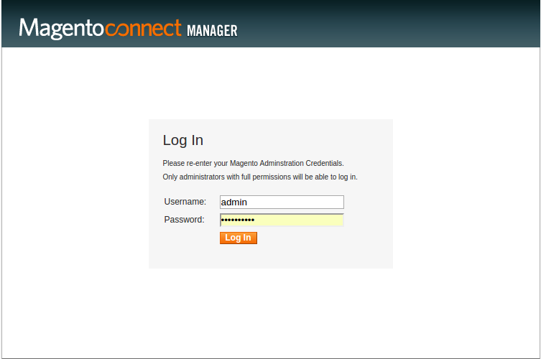

Step 2: Extension Installation
1. In the Extension tab >> Direct package file upload, upload the Targetbay_Tracking-1.4.3.tgz
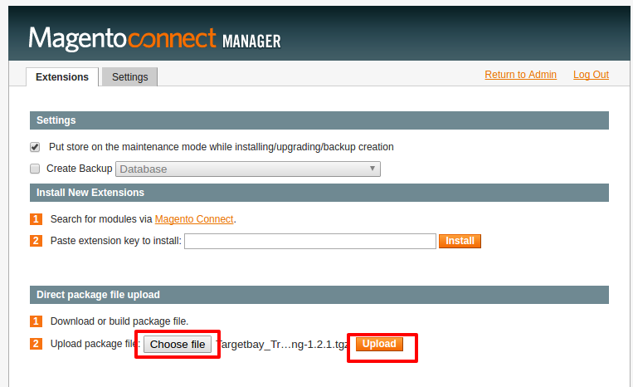
2. Wait till you get the successful installation notification.
3. Click Browser “Refresh” to finish.

Step 3: Targetbay Configuration
1. In the top of “Magento Connect Manager”, click “Return to admin button”.
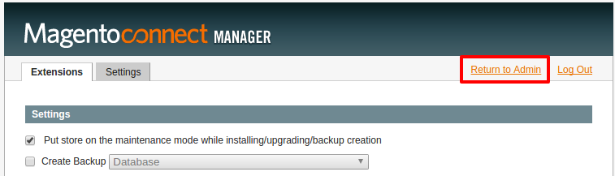
2. Clear the cache from System -> Cache Management select all checkbox and click “Refresh” button. Logout and login again.
3. Go to the System -> Configuration -> Tracking configuration, Enter the Targetbay Hostname, API Status, Api Token and Api Index. Change Enable Module:Status to "disabled"

Hostname: dev: https://dev.targetbay.com/api/v1/webhooks/
Hostname: live: https://app.targetbay.com/api/v1/webhooks/
For DEV :API Status Dev: Development
For Live :API Status:production
API Index :
API Token :
Disable Email :Magento welcome mail to No

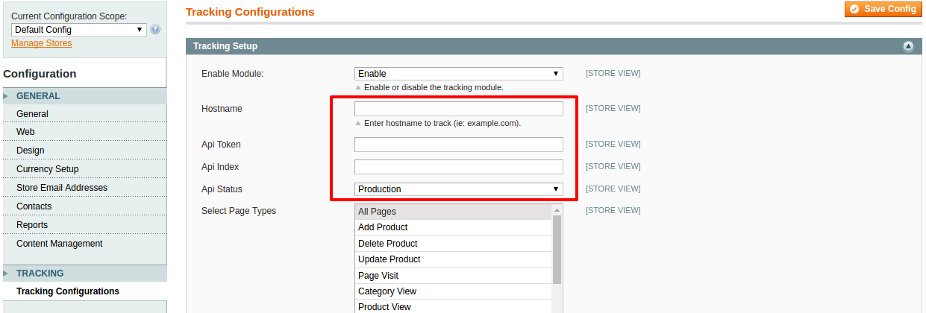
3. Click “Save Config” button in top right corner of the screen.

Step 4: Configure Magento REST API Settings

1. Creating oAuth Consumer
Since Magento REST service is working only with oAuth authentication, we need to create oAuth consumer application first. Navigate to System->Web Services ->REST oAuth Consumers. OAuth Consumers grid is shown. We can register any number of Consumers in Magento that can be used by various third party oAuth clients to access our Magento resources.

- Click on “Add New” button to add new Consumer Application.
- On “Consumer” screen insert some custom name "TargetBay.
- Key and Secret fields are disabled, and we just need to copy their values somewhere in text file for later usage (We need them for our oAuth authorization in order to be able to consume REST from Magento).
- We can leave the Callback URL and Rejected Callback URL fields empty for now.
- Save Consumer app.
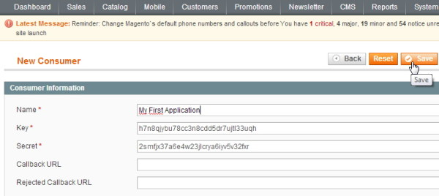

2. Creating and configuring Admin roles
We need to create permissions for specific user type in order user to be able to consume Magento REST service and access necessary resources.
Let’s navigate to System -> Web Services -> REST Roles. REST Roles grid is shown with two user types by default:
- Customer
- Guest
For Targetbay, we need Admin permissions.
Let’s create new Admin role.
- Click on “Add admin Role” button in top right corner. “Add new Role” screen is shown.
- In the field “Role name” enter for example “Admin”.
- Click on “Role API resources” tab on the left.
“Role Resources” screen is shown and here we need to check specific permissions that our Administrator user will have on specific resource. Of course, we have an option to select “All”.
- Click on “Save Role” button in top right corner of the screen.
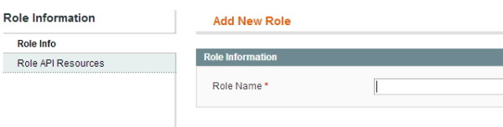

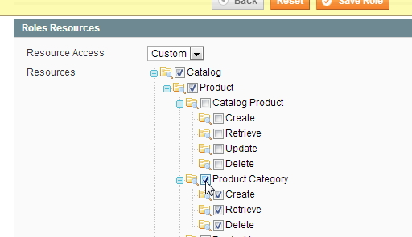

3. Configuring resource attributes and access permissions
Navigate to System->Web Services ->REST attributes.
Here we have grid with three user types listed:
- Admin
- Customer
- Guest
- Let’s click on “Admin” in order to configure REST resource attributes that Admin will be allowed to access.
- Under “User type resources” screen, select resources that Admin user type can access or select “All“.
- Click on “Save” button in the top-right corner.
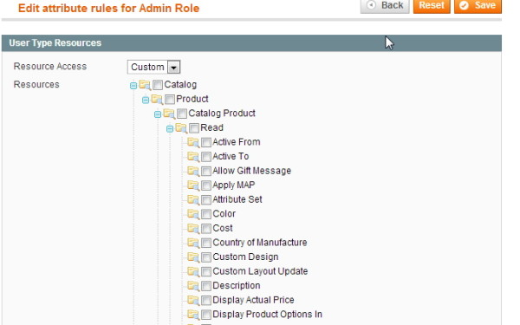

4. Assigning configured Admin REST Role to existing admin user
We did everything to configure resources for Admin user type, but we didn’t assign any user to this roles.
- Navigate to System->Permissions->Users. “Users” grid is shown with list of registered Magento site Administrators
- Click on Targetbay admin user from list in order to open “Edit user” screen.
- There is a tab named “REST role” on the left. Click on it and a list of Admin type roles is shown on the screen.
- Click on “Assigned” radio box near that role name.
- Save User.
You have successfully assigned the admin user to be able to access REST resources on our Magento.
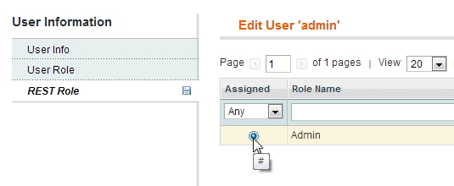
Then goto app.targetbay.com into Settings>>Connect Website
API Url * - Your website URL
Admin URL: Admin URL

Copy & Paste : Consumer Key and Secret from earlier step

In tracking configuration If Full page cache - Set Manual, If not automatic.

